**CHAPTER 1**

**INTRODUCTION**

Machine learning (ML) has emerged as a transformative force, revolutionizing various domains with its ability to extract patterns and insights from data. In this project, we embark on a journey through the landscape of ML techniques, tracing their historical evolution and leveraging their power to address the fundamental challenge of iris flower classification. Rooted in the rich history of ML, our endeavour integrates advanced algorithms and Python programming, symbolizing the convergence of tradition and innovation in the pursuit of scientific inquiry.

The roots of machine learning can be traced back to the mid-20th century, when pioneers such as Alan Turing and Arthur Samuel laid the groundwork for computational systems capable of learning from data. The advent of neural networks in the 1980s marked a significant milestone, followed by the resurgence of interest in ML driven by advancements in computing power and data availability in the 21st century. Today, ML stands at the forefront of technological innovation, permeating diverse fields ranging from healthcare to finance, and beyond.

The classification of iris flower species represents a quintessential challenge in ML, epitomizing the paradigm of supervised learning. Our task entails discerning between three distinct iris species—Setosa, Versicolor, and Virginica—based on their morphological attributes. This endeavour is characterized by its complexity stemming from the subtle variations in petal and sepal measurements across different species, underscoring the need for sophisticated ML techniques to achieve accurate classification.

Python has emerged as the de facto programming language for ML, owing to its simplicity, versatility, and a robust ecosystem of libraries such as scikit-learn and TensorFlow. Guido van Rossum's creation has witnessed widespread adoption within the ML community, facilitating seamless integration of algorithms and enabling rapid prototyping and experimentation. Python's ascendancy in ML reflects its capacity to democratize access to cutting-edge technologies and empower researchers and practitioners to unlock the full potential of machine learning.

Through the synergistic fusion of advanced algorithms, Python programming, and a deep appreciation for the complexities of nature, we endeavour to unravel the mysteries of floral taxonomy and contribute to the collective body of knowledge in both ML and botanical sciences

**1.1 OBJECTIVES**

* **Primary Objective:** Implement various machine learning algorithms for iris flower classification.
* **Learning and Exploration:** Gain insights into the effectiveness of logistic regression, k-nearest neighbours, random forest, SVM, naive Bayes, and decision tree algorithms in iris flower classification. Explore the nuances of each algorithm and their suitability for the task.
* **Performance Metrics:** Evaluate the performance of the implemented algorithms using metrics such as accuracy, precision, and recall. Determine which algorithms yield the highest classification accuracy for iris flower species.
* **Iterative Development:** Engage in iterative development by refining the implementation based on performance metrics and comparative analysis. Continuously improve the classification models to achieve optimal accuracy and reliability.

**1.2 METHODOLOGIES**

The project aims to systematically evaluate and compare the effectiveness of different machine-learning techniques for iris flower classification.

Here's how a typical music recommendation system employing collaborative filtering works:

* **Data Pre-processing:** Perform data cleaning to handle missing values and outliers. Standardize or normalize the feature values to ensure consistency across the dataset. Split the dataset into training and testing subsets for model evaluation.
* **Algorithm Selection:** Choose a variety of machine learning algorithms suitable for classification tasks, including logistic regression, k-nearest neighbours, random forest, SVM, naive Bayes, and decision tree algorithms. Consider the characteristics of the dataset and the nature of the classification problem when selecting algorithms.
* **Model Training and Evaluation:** Train each selected algorithm using the Model training subset of the dataset. Adjust hyperparameters to optimize model performance, utilizing techniques such as cross-validation to prevent overfitting. Evaluate the trained models using performance metrics such as accuracy, precision, recall, and F1-score. Utilize confusion matrices and ROC curves to assess the models' classification performance comprehensively.

**1.2.1 Advantage**

* **High Accuracy:** Machine learning algorithms can achieve high accuracy in classifying iris flower species, especially when trained on large and diverse datasets.
* **Automation:** Once trained, the classification system can automate the process of identifying iris flower species, reducing the need for manual intervention and speeding up the classification process.
* **Scalability:** The system can scale to handle large volumes of data, making it suitable for applications with extensive datasets or real-time classification requirements.
* **Generalization:** Well-trained machine learning models can generalize well to unseen data, meaning they can accurately classify iris flower species even for instances not encountered during training.
* **Flexibility**: Machine learning algorithms offer flexibility in terms of model selection, allowing researchers to experiment with different algorithms and techniques to achieve optimal classification performance.

**1.2.2 Limitations:**

* **Dependence on Data Quality:** The performance of the classification system heavily relies on the quality and representativeness of the training data. Poor-quality or biased data can lead to inaccurate classification results.
* **Overfitting:** Machine learning models may overfit to the training data, capturing noise or irrelevant patterns that do not generalize well to new data. This can result in reduced performance on unseen instances.
* **Interpretability:** Some machine learning algorithms, particularly complex models like neural networks, lack interpretability, making it challenging to understand the rationale behind their classification decisions.
* **Computational Resources:** Training and deploying machine learning models can require significant computational resources, including memory, processing power, and storage, especially for large-scale datasets or complex algorithms.
* **Algorithm Selection**: The choice of a machine learning algorithm can significantly impact the classification performance. Selecting the most appropriate algorithm for a specific task requires expertise and experimentation.

Despite these limitations, the advantages of using machine learning for iris flower classification outweigh the challenges, offering a powerful and efficient solution for automated species identification in botanical research and related fields.

**1.3 EXISTING SYSTEM**

In the realm of botanical research and machine learning, iris flower classification stands as a classic benchmark problem. Several existing systems have been developed to address this task, leveraging various machine learning algorithms and methodologies. One prominent example is the iris classification system implemented using Python's scikit-learn library, which offers a comprehensive suite of tools for machine learning tasks.

The existing iris classification system follows a systematic approach to accurately classify iris flower species based on their morphological attributes. The system comprises several key components, including data pre-processing, algorithm selection, model training, evaluation, and deployment.

The system begins by collecting a dataset of iris flower instances, typically the well-known Iris dataset consisting of 150 samples with measurements of petal length, petal width, sepal length, and sepal width, along with their corresponding species labels (Setosa, Versicolor, Virginica). The dataset undergoes pre-processing steps to handle missing values, remove outliers, and standardize or normalize feature values to ensure uniformity and facilitate model convergence.

Next, the system selects suitable machine learning algorithms for iris flower classification. Commonly employed algorithms include logistic regression, k-nearest neighbours, random forest, support vector machine, naive Bayes, and decision tree algorithms. Each algorithm is chosen based on its appropriateness for the classification task, computational efficiency, and potential to achieve high accuracy.

The selected algorithms are trained using the pre-processed dataset, where they learn to associate patterns in the input features with the corresponding iris flower species labels. Model training involves adjusting the algorithms' parameters to minimize a chosen loss function, typically cross-entropy loss, and optimize classification performance.

The trained models are evaluated using a separate testing dataset to assess their performance and generalization capabilities.

**1.3.1 DISADVANTAGES**

* **Data Imbalance:** The existing iris classification system may encounter issues related to class imbalance within the dataset. If certain iris species are underrepresented compared to others, the models may exhibit bias towards the majority classes, leading to suboptimal performance in accurately classifying minority classes.
* **Limited Feature Space:** The system relies solely on morphological attributes such as petal and sepal measurements for classification. This limited feature space may overlook other potentially informative features, such as color or texture, which could enhance the accuracy and robustness of the classification system.
* **Sensitivity to Input Variations:** Machine learning models trained on a specific dataset may be sensitive to variations in input data, such as differences in measurement techniques or environmental conditions. These variations can affect the models' generalization capabilities and lead to inconsistencies in classification performance across different datasets or settings.
* **Lack of explanation:** Collaborative filtering algorithms often provide recommendations based solely on past user behavior without providing any explanation for why a particular item was recommended. This lack of transparency can lead to frustration and distrust among users who don't understand why certain recommendations are being made.
* **Difficulty in Handling Noisy Data:** Real-world datasets often contain noise or errors due to measurement inaccuracies or data collection artifacts. The existing system may struggle to effectively handle noisy data, leading to suboptimal model performance and reduced accuracy in iris species classification.
* **Limited Interpretability:** While machine learning algorithms excel at pattern recognition and classification tasks, their decision-making processes are often opaque and difficult to interpret. The lack of interpretability in model predictions may hinder the system's acceptance and trustworthiness in practical applications, particularly in domains where explain ability is crucial.
* **Resource Intensiveness:** Training and deploying machine learning models, especially complex algorithms like neural networks or ensemble methods, can be resource-intensive in terms of computational power, memory, and storage requirements. This resource intensiveness may pose challenges for deployment in resource-constrained environments or on edge devices with limited computing capabilities.
* **Domain Specificity:** The iris classification system is tailored specifically for iris flower classification and may not be easily adaptable to classify other types of flowers or botanical species. Generalizing the system to handle diverse botanical datasets or species identification tasks may require significant modifications or retraining of the models.
* **Ethical Considerations:** As with any machine learning system, the existing iris classification system may raise ethical concerns related to data privacy, algorithmic bias, and unintended consequences. Careful consideration of ethical implications and responsible deployment practices is essential to ensure the system's ethical and equitable use in botanical research and related applications.

**1.4 PROBLEM STATEMENT**

The task at hand revolves around the intricate challenge of accurately classifying iris flower species based on their morphological attributes. Specifically, the objective is to develop a robust machine learning model capable of distinguishing between three distinct iris species—Setosa, Versicolor, and Virginica—using features such as petal length, petal width, sepal length, and sepal width. The classification of iris species serves as a quintessential problem in supervised learning, necessitating the exploration and implementation of sophisticated machine learning techniques.

The inherent complexity of the problem stems from the subtle variations in petal and sepal measurements across different iris species, posing a formidable challenge for traditional classification methods. Moreover, the dataset comprising 200 meticulously annotated instances further amplifies the intricacy of the task, requiring a nuanced approach to feature extraction, model training, and evaluation.

The successful resolution of this problem holds significant implications for both the field of machine learning and botanical sciences. Accurate classification of iris species not only showcases the efficacy of advanced ML algorithms but also contributes to our understanding of floral diversity and taxonomy. Furthermore, the development of a reliable classification model lays the groundwork for broader applications in species identification, biodiversity conservation, and ecological research.

Thus, the problem statement encapsulates a multifaceted challenge with far-reaching implications, underscoring the importance of leveraging cutting-edge technologies to address real-world problems in interdisciplinary domains.

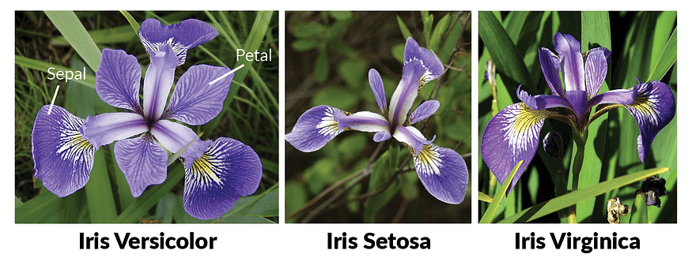

Fig 1.4 Three species of IRIS flower

**1.5 PROPOSED SOLUTION**

The project seeks to not only address the immediate challenge of iris flower classification but also pave the way for future advancements in the intersection of machine learning and botanical sciences. Specifically, the goals include:

**Automation:** Develop a machine learning system capable of automating the classification of iris flower species, reducing the need for manual intervention in the identification process.

**Accuracy:** Achieve high levels of accuracy in iris species classification, ensuring reliable and consistent results across different instances and datasets.

**Efficiency:** Optimize the performance of the machine learning algorithms to ensure computational efficiency, minimizing processing time and resource utilization.

**Scalability:** Design the classification system to be scalable, capable of handling larger datasets and accommodating future growth in data volume and complexity.

**Foundation for Further Applications:** Establish a solid foundation for further applications of machine learning in botanical sciences and related domains. Provide insights and methodologies that can be extended to other classification tasks, contributing to broader advancements in artificial intelligence research.

classify iris flower species based on their morphological attributes. Here's a breakdown of how these algorithms achieve accurate classification:

**Algorithm Selection:**

Logistic Regression, k-nearest Neighbours, Random Forest, Support Vector Machine, Naive Bayes, and Decision Tree algorithms are selected for their suitability in classification tasks.

Each algorithm brings unique strengths to the task, from the simplicity of logistic regression to the complexity of ensemble methods like random forest.

**How Training Works:**

**Initialization:** The training process begins with the initialization of the machine learning algorithms' parameters. For instance, in logistic regression, the weights are initialized randomly.  
**Forward Pass:** Labeled instances from the training dataset are fed into each algorithm. The algorithms process the input data through their respective mathematical computations, progressively uncovering patterns in the relationships between petal and sepal measurements and iris species.

**Prediction:** After processing the input data, each algorithm produces a prediction or probability distribution over the possible iris flower species. For example, a logistic regression model might output probabilities for each class, indicating the likelihood of an instance belonging to Setosa, Versicolor, or Virginica.

**Error Calculation:** The predictions made by the algorithms are compared to the true labels of the training instances. The error or loss is calculated using a suitable loss function, such as cross-entropy loss for multi-class classification tasks. This error quantifies the discrepancy between the predicted and true labels for each training instance.

**Backpropagation:** Backpropagation is a key algorithmic technique used to update the parameters (e.g., weights) of the algorithms based on the calculated error. It involves computing the gradients of the loss function concerning the model parameters. These gradients provide information on how to adjust the parameters to minimize the error.

**Repeat:** The training process iterates over the entire training dataset multiple times, known as epochs. With each epoch, the algorithms update their parameters based on the gradients computed from different batches of training data.

**Key Components:** The process of building and utilizing the iris classification solution involves several crucial steps:

**Data Collection and Pre-processing:**

Collecting a comprehensive dataset of iris flower instances, including petal and sepal measurements for each sample.

Pre-processing the dataset by handling missing values, removing outliers, and standardizing or normalizing the feature values to ensure consistency and facilitate algorithm convergence.

**Model Training:**

Dividing the dataset into training and testing subsets to facilitate model training and evaluation.

Training each selected algorithm using the training data, allowing the models to learn from the patterns present in the input features and their corresponding iris flower species labels.

**Evaluation Metrics:**

Employing appropriate evaluation metrics, such as accuracy, precision, recall, and F1-score, to assess the performance of the trained models.

These metrics provide insights into the algorithms' ability to correctly classify iris flower species and their overall effectiveness in solving the classification task.

**1.6 PROPOSED ALGORITHM**

Segmentation serves to eliminate the unwanted background, isolating the focal point (foreground) object, namely the flower. Its primary aim is to streamline the depiction of the flower, presenting a more discernible and analytically manageable entity.

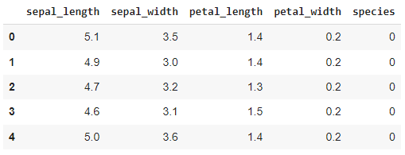In the process of Feature Extraction, we derive essential characteristics or information from the flower, represented as real values such as floats, integers, or binaries. Key features used for quantifying plants or flowers include colour, shape, and texture. Rather than relying solely on a single feature vector, we opt for a comprehensive approach, combining different feature descriptors to more effectively identify the image. Table 1 showcases the representation of the initial five Iris datasets.

Fig 1.5.1 IRIS data set samples

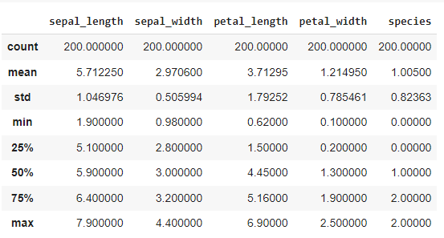Upon extracting features and labels from the Iris dataset, the subsequent step entails training the system. Utilizing scikit-learn, we construct machine-learning models capable of classifying Iris flowers into their respective subspecies. The descriptive statistics of the Iris dataset are delineated in Table 2 below.

Fig 1.5.2 Summary of IRIS data

Feature extraction methodically extracts pertinent properties or data points from the flowers, encapsulating them as real values such as floats, integers, or binaries. Employing a diverse array of techniques including Logistic Regression, Decision Tree, k-nearest Neighbour, Random Forest Classifier, Gaussian Naive Bayes, and Linear SVC further bolsters the accuracy and reliability of the classification process.

1. **Decision tree**

The Decision Tree stands out as the primary tool for AI and ML-based predictions, renowned for its effectiveness and widespread usage. Each leaf node holds a class label, while branches denote outcomes, and internal nodes represent attribute tests. This tree-based structure resembles flow charts and finds applications in both regression and classification tasks. Notably, decision trees are characterized by their simplicity and lack of parameters, enabling the creation of models that forecast variable values using straightforward decision rules.

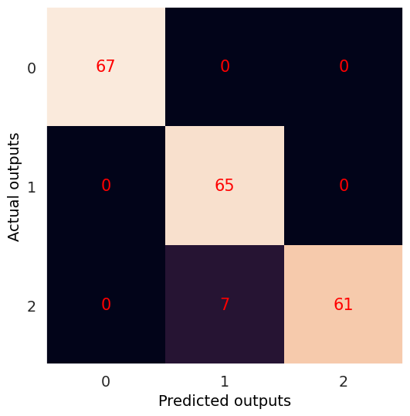

Fig 1.5.3 Decision tree confusion matrix

1. **Random forest classifier**

In the training phase, the ensemble learning approach of random forest constructs decision tree models. These models collectively contribute to the final decision-making process. Random forest, a classification method in machine learning, operates by creating an ensemble of trees. Unlike decision trees that utilize the entire dataset and consider all attributes, random forest uses only a subset of the data and a limited number of features.

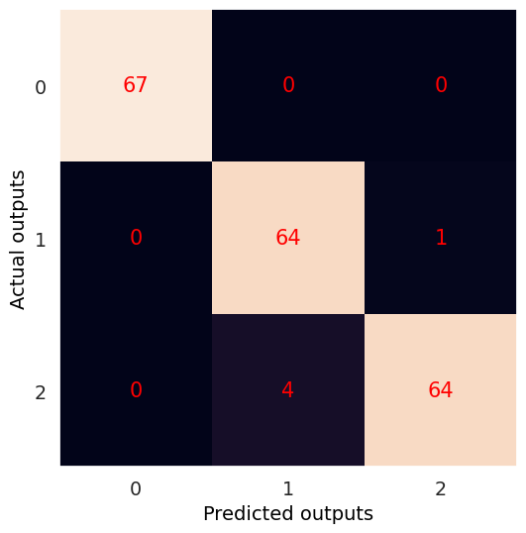

Fig 1.5.4 Random Forest Classifier confusion matrix

1. **Gaussian Naive Bayes**

Gaussian Naive Bayes, a statistics-driven classification method rooted in Bayes Theorem, operates under stringent independence assumptions. These conditions dictate that alterations in one value do not affect another. While the performance of naive Bayes classifiers may decline with larger training sets, they remain renowned for their expressive nature, scalability, and moderate accuracy in machine learning. The efficiency of these classifiers is influenced by various factors.

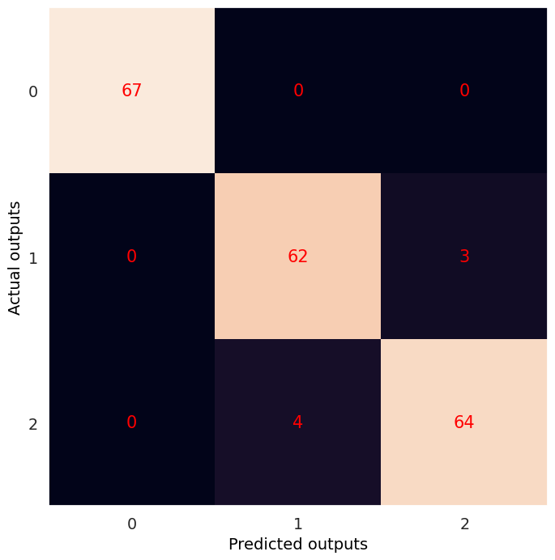

Fig 1.5.5 Naïve Bayes confusion matrix

1. **Logistic Regression**

Logistic regression estimates event occurrence likelihood using a logistic function. It employs predictor variables, whether numerical or categorical, akin to other regression types. Specifically designed for binary data, it determines event occurrence (1) or non-occurrence (0) based on features.



Fig 1.5.6 Logistic regression confusion matrix

1. **K-Nearest Neighbours (KNN)**

K-Nearest Neighbours (KNN) is a supervised learning technique widely employed for classification tasks, utilizing the entire dataset during prediction. When presented with new data, KNN searches for the k most similar instances within the training dataset and predicts the class of the new data based on the majority class among its nearest neighbors. This method retains all available examples and determines the classification of new instances based on their similarity to existing data points.

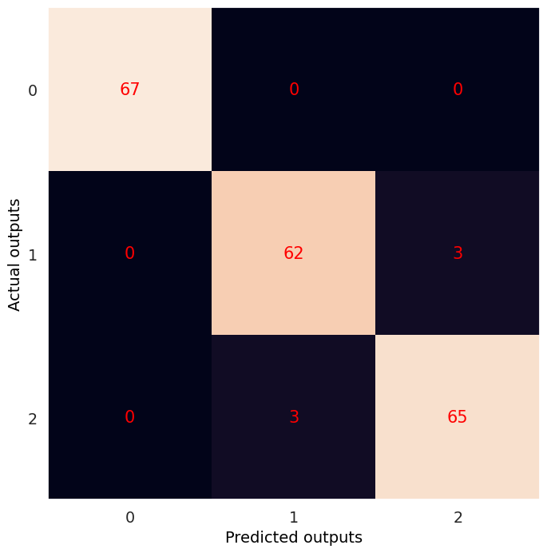

Fig 1.5.7 KNN confusion matrix

1. **Support Vector Machine**

Support Vector Machine (SVM) is a supervised learning method commonly utilized in classification tasks, which operates by analysing the entire dataset during the training phase. When making predictions on unseen data, SVM identifies the optimal hyperplane that best separates different classes in the feature space. It then assigns the class label to the new data point based on its position relative to this hyperplane. SVM retains crucial support vectors from the training data to define the decision boundary for classifying new instances.



Fig 1.5.8 Support Vector Machine confusion matrix

**1.7 ADVANTAGES**

* **Personalized Recommendations:** Collaborative filtering allows for the generation of personalized recommendations based on the preferences of similar users. This means that users are more likely to discover new music that aligns with their tastes and interests.
* **No Explicit Item Metadata Required:** Unlike content-based recommendation systems, collaborative filtering does not rely on explicit item metadata such as genre or artist tags. This makes it particularly useful for recommending niche or lesser-known music where such metadata might be sparse or inaccurate.
* **Ability to Discover Diverse Music:** By leveraging the preferences of a large user base, collaborative filtering can recommend a diverse range of music genres and artists. This helps users discover music that they may not have otherwise encountered, thereby broadening their musical horizons.
* **Adaptability to User Preferences:** Collaborative filtering systems continuously adapt to changes in user preferences over time. As users interact with the system and provide feedback on recommended music, the recommendations become increasingly tailored to their evolving tastes.
* **Scalability:** Collaborative filtering techniques can scale effectively to accommodate a growing number of users and items in the music catalogue. This scalability makes it suitable for large-scale music recommendation platforms with millions of users and extensive music libraries.
* **Serendipitous Discovery:** Collaborative filtering can facilitate serendipitous discovery by recommending music that users may not have explicitly sought out but are likely to enjoy based on the preferences of similar users. This can lead to delightful discoveries and enhance the overall user experience.
* **Implicit Feedback Handling:** Collaborative filtering can effectively handle implicit feedback, such as user listening history or implicit ratings inferred from user interactions with the system. This enables the system to generate accurate recommendations even when explicit feedback is limited.
* **Robustness to Cold Start Problem:** Collaborative filtering can mitigate the cold start problem, where new users or items have limited interaction history.

**CHAPTER 2**

**LITERATURE SURVEY**

Multiple studies utilize diverse machine learning algorithms, including XGBoost, K-Nearest Neighbor (KNN), Support Vector Machine (SVM), Decision Trees, and Random Forests, to classify Iris flowers accurately. These studies emphasize the importance of accuracy, showcasing exceptional results with approximately 100% accuracy. The rich biodiversity of Earth and the challenges posed by similar physical characteristics among species underscore the relevance of these classification efforts[10].

As the field of ML continues to evolve, Iris flower classification remains a valuable domain for exploring the capabilities of various algorithms and advancing the understanding of pattern recognition and classification [11]

Classification algorithms within the field of machine learning are crucial for categorizing data into distinct classes, making them invaluable for tasks like data mining. The process of selecting the most suitable classification model, one that offers both high accuracy and efficiency, is both important and challenging. To address this issue, this research paper conducts a comparative analysis of Multilayer Perceptron (MLP) in conjunction with various other ML methods, including KNN, SVM, Logistic Regression, Decision Trees, and Random Forests.[12]

The Iris dataset is well-known, and it contains data with four attributes: Sepal.length, Sepal.width, Petal.length, and Petal.width. It is divided into three separate groups or subspecies, Sentosa, Versicolor, and Virginica, each with 50 samples. The measurements for these attributes are in centimeters. Ronald Fisher created this dataset in 1936, and it is easily accessible through the UCI dataset repository. This research will show how to solve classification problems using several methods such as K-means clustering, Random Forest decision, SVM, LR, KNN, and K-means. In addition, we investigate the translation of the four features into advanced features.[13]

This topic presented that classification is very common in modern machine learning, and it is widely used in a variety of domains such as face recognition, flower categorization, clustering, and other applications. The primary goal of this research project is to methodically arrange and classify a group of data objects. The study used the K-nearest neighbors, decision tree (j48), and random forest methods to accomplish this. Following that, it evaluates and compares their performance using the IRIS dataset.

The results of this comparison analysis show that the K-nearest neighbors algorithm outperforms the other classifiers in terms of performance. Furthermore, when compared to the decision tree (j48), the random forest classifier outperforms it. Surprisingly, the research produced a 100% accuracy rate with no errors for the used classifier.[14]

An ML technique is employed to predict the membership of data instances in specific groups or categories. To streamline the classification process, neural networks are being introduced. This research paper is centered around the classification of IRIS plants using Neural Networks as a tool. The core problem addressed in this study revolves around identifying the species of IRIS plants based on measurements of various plant attributes. The classification of the IRIS dataset involves the extraction of discernible patterns by analyzing the sizes of petals and sepals in IRIS plants.[15]

**CHAPTER 3**

**SOFTWARE REQUIREMENTS SPECIFICATION**

To effectively implement iris flower classification using machine learning, it's crucial to ensure that the system meets specific hardware and software requirements. These requirements encompass both hardware specifications and software dependencies necessary for data processing, model training, and deployment.

**3.1 SPECIFIC REQUIREMENTS**

**Data Acquisition:** Obtain a comprehensive dataset of iris flower instances, including measurements of petal length, petal width, sepal length, and sepal width, along with their corresponding species labels (Setosa, Versicolor, Virginica).

**Programming Language Support:** Ensure compatibility with Python programming language, preferably version 3.x, as the primary language for implementing machine learning algorithms and data processing tasks.

* **Machine Learning Toolkit Integration:**
* **scikit-learn:** Integrate the scikit-learn library for implementing machine learning algorithms, data pre-processing, and model evaluation tasks.
* **TensorFlow and Keras:** Incorporate TensorFlow and Keras frameworks for building and training deep learning models, facilitating the implementation of complex neural network architectures.
* **Numpy and Pandas:** Utilize NumPy for numerical computations and Pandas for data manipulation tasks, enabling efficient handling of large datasets.
* **Development Environment Compatibility:**
* **Jupyter Notebook:** Provide compatibility with Jupyter Notebook, an interactive computing environment, for developing, documenting, and sharing code.
* **PyCharm or Anaconda Navigator:** Support PyCharm or Anaconda Navigator as integrated development environments (IDEs) for Python development, offering tools for code editing, debugging, and project management.
* **Visualization Toolkit Integration:**
* **Matplotlib and Seaborn**: Integrate Matplotlib and Seaborn libraries for data visualization tasks, allowing the creation of plots, charts, and graphs to visualize data distributions and model performance metrics.
* **Optional Database Support:**
* SQLite or PostgreSQL: Provide optional support for SQLite or PostgreSQL as lightweight database management systems (DBMS) for storing and managing datasets, especially for applications requiring data persistence and scalability.

**3.1.1 HARDWARE SPECIFICATION**

**Processor:** A multi-core processor with sufficient processing power to handle complex computations involved in model training and evaluation. A modern CPU with multiple cores (e.g., Intel Core i5 or AMD Ryzen) is recommended.

**Memory (RAM):** Adequate RAM is essential for loading datasets into memory, performing computations, and storing intermediate results during model training. A minimum of 8 GB RAM is recommended, with higher capacities preferred for handling larger datasets or memory-intensive algorithms.

**Storage:** Sufficient storage space is required for storing datasets, model files, and related resources. Solid-state drives (SSDs) are preferred for faster data access and improved system responsiveness.

**Graphics Processing Unit (GPU):** While not mandatory, a dedicated GPU with CUDA support can significantly accelerate model training, especially for deep learning algorithms. GPUs from NVIDIA (e.g., GeForce GTX or Quadro series) are commonly used for parallel processing and accelerating matrix operations in deep learning frameworks like TensorFlow and PyTorch.

**3.1.2 SOFTWARE REQUIREMENTS**

**Python:** The system relies on Python, a versatile programming language renowned for its simplicity and extensive libraries for scientific computing and machine learning.

**Development Environment:** An integrated development environment (IDE) such as Jupyter Notebook, PyCharm, or Anaconda Navigator provides a user-friendly interface for writing, executing, and debugging Python code.

**Machine Learning Libraries:** Installation of machine learning libraries is essential for implementing algorithms, data pre-processing, and model evaluation. Commonly used libraries include:

**scikit-learn:** A powerful library for machine learning tasks, offering a wide range of algorithms and tools for classification, regression, clustering, and dimensionality reduction.

**TensorFlow:** An open-source deep learning framework developed by Google, widely used for building and training neural networks.

**Keras**: A high-level neural networks API built on top of TensorFlow, offering a user-friendly interface for building and training deep learning models.

**NumPy and Pandas:** Fundamental libraries for numerical computing and data manipulation, respectively, providing efficient data structures and operations for handling large datasets.

**Visualization Libraries:** Visualization libraries such as Matplotlib and Seaborn are useful for visualizing data distributions, model performance metrics, and decision boundaries.

**Database Management System (Optional):** Integration with a database management system (DBMS) may be necessary for storing and managing large datasets efficiently. Popular options include MySQL, PostgreSQL, SQLite, and MongoDB.

**CHAPTER 4**

**SYSTEM DESIGN&ARCHITECTURE**

**4.1.1 SYSTEM ARCHITECTURE**

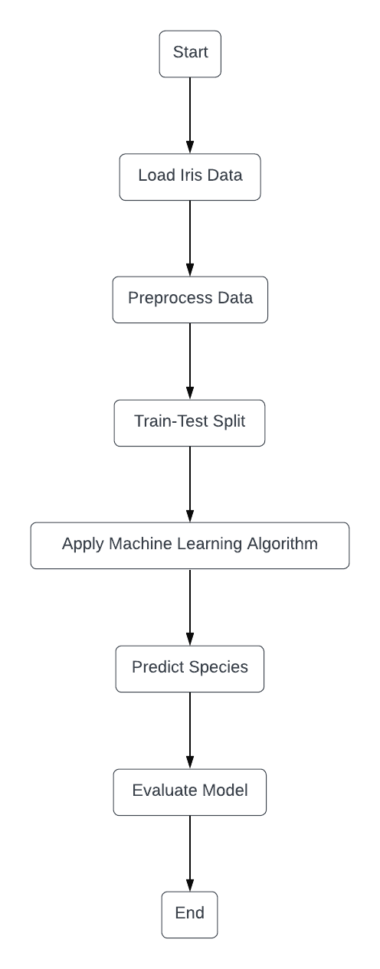

**Fig. 4.1 Flowchart Diagram**

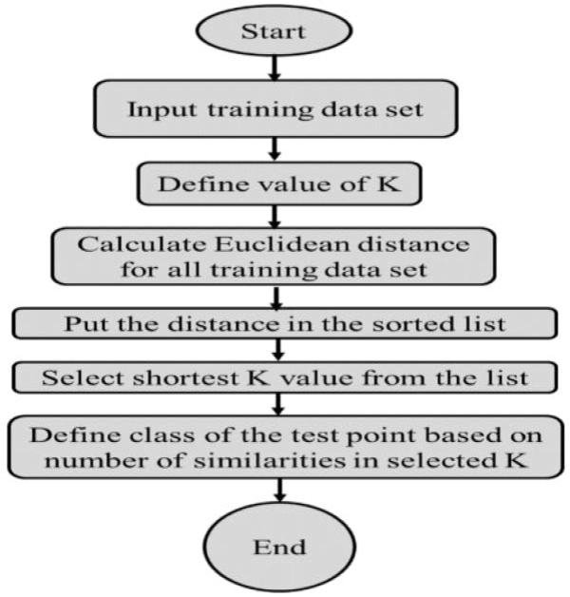

**Fig 4.2 K-Nearest Neighbors Flow chart**

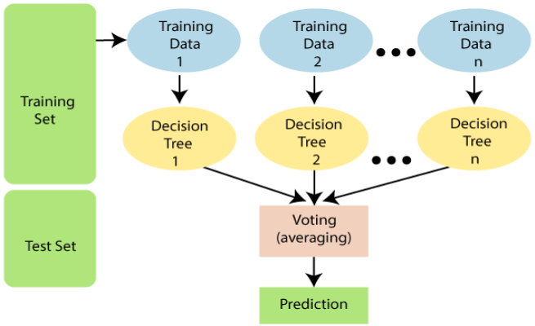

**Fig 4.3 Random Forest Algorithms Structure for the training dataset**

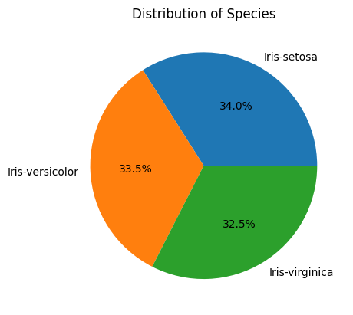

**Fig 4.4 IRIS data set Phi-chart**

**CHAPTER 5**

**RESULT**

Graph:  
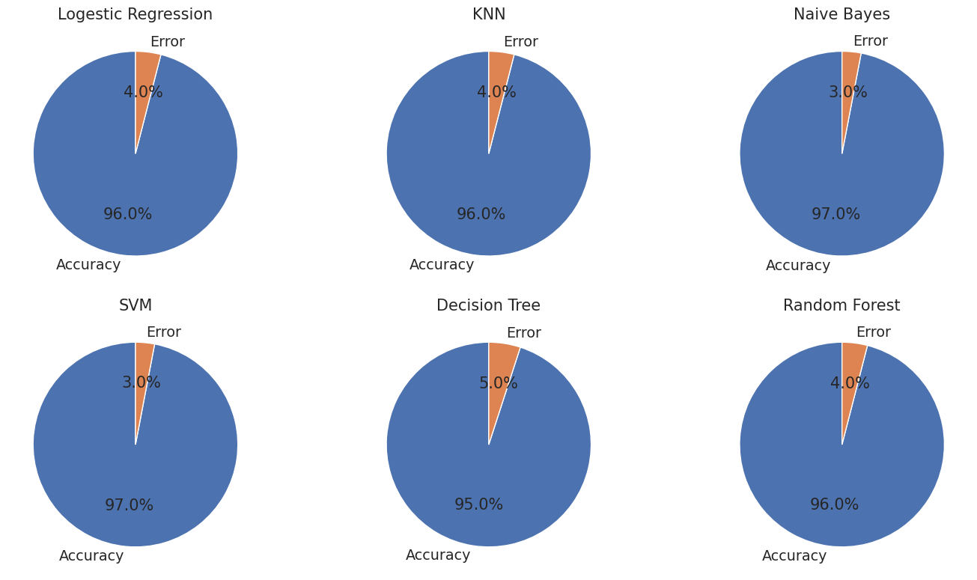

Fig 6.1 Pie Chart of 6 ML Models Accuracy and Error

Accuracy:  
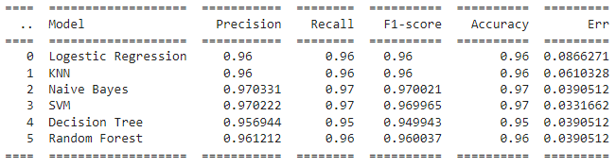

Fig 6.2 Precision, Accuracy, Recall, F1 Score of Classification Model

**CHAPTER 6**

**CONCLUSION**

In this project, we delved into the realm of supervised machine learning, specifically focusing on Iris Flower Classification. Leveraging six diverse machine learning models - k-Nearest Neighbors, Logistic Regression, Decision Tree, SVM, Naive Bayes, and Random Forest classifier - we aimed to construct robust models capable of accurately predicting iris flower species. Through extensive data visualization, analysis, and model construction, we gained valuable insights into the intricacies of the iris dataset and the performance of various algorithms. Our findings suggest that Logistic Regression emerges as the most accurate classifier among the six models tested. Moving forward, the overarching goal of supervised learning remains to build models that generalize well to unseen data, ensuring accurate predictions for future iris flowers beyond the scope of our training dataset.

**CHAPTER 7**

**FUTURE SCOPE**

In the future, the Iris Flower Classification Project holds significant potential for advancement in several key areas. Firstly, there's room for enhancing the performance of the classification models by delving into more sophisticated machine-learning techniques, optimization algorithms, and ensemble methods.

Additionally, further exploration into feature engineering could involve investigating additional morphological features or extracting higher-level features from images to bolster the discriminative power of the models. The integration of deep learning architectures, such as convolutional neural networks (CNNs) or recurrent neural networks (RNNs), presents another avenue for improvement, leveraging their ability to capture intricate patterns and relationships in data.

Transfer learning techniques also offer promise in adapting pre-trained models from related domains, reducing the need for extensive training data and computational resources. The project could also expand into real-time deployment scenarios, enabling the development of classification systems capable of processing iris flower images captured from live or streaming sources.

Optimization for mobile and edge computing platforms could further extend the project's reach, allowing for decentralized classification tasks and offline usage in remote environments. Integration of additional modalities like color images, infrared imaging, or spectral data could enhance the robustness of the classification system across diverse environmental conditions.

Moreover, there's potential to broaden the project's scope to include other plant species or botanical datasets, facilitating applications in biodiversity conservation, species monitoring, and ecological research. Furthermore, the development of human-in-the-loop systems that incorporate human feedback and expert knowledge could refine model predictions, improve interpretability, and address uncertainties in classification tasks.

Collaborative research efforts involving botanical experts, ecologists, and researchers could validate classification results, gather domain-specific insights, and integrate domain knowledge into the model development process. Lastly, ethical considerations such as data privacy, algorithmic bias, and responsible AI practices should be carefully addressed throughout the project's lifecycle to ensure ethical and equitable deployment of the classification system.

**REFERENCES**

**[1]** J. P. Pinto, S. Kelur and J. Shetty, "Iris Flower Species Identification Using Machine Learning Approach," 2018 4th International Conference for Convergence in Technology (I2CT), Mangalore, India, 2018, pp. 1-4, doi: 10.1109/I2CT42659.2018.9057891.

**[2]** T. Gupta, P. Arora, R. Rani, G. Jaiswal, P. Bansal and A. Dev, "Classification of Flower Dataset using Machine Learning Models," 2022 4th International Conference on Artificial Intelligence and Speech Technology (AIST), Delhi, India, 2022, pp. 1-6, doi: 10.1109/AIST55798.2022.10065178.

**[3]** Asmita Shukla, Ankita Agarwal, Hemlata Pant, and Priyanka Mishra, “Flower Classification using Supervised Learning,” Int. J. Eng. Res., vol. Vol.9, no. 05, pp.757–762, 2020.

**[4]** <https://www.kaggle.com/datasets/abhayku2002/iris-flower-dataset>

**[5]** k- Nearest Neighbor from Kaggle by skalskip available at <https://www.kaggle.com/skalskip/iris-data-visualization-and-knn-classification>

**[6]** Support Vector Machine from Kaggle by Moghazy available at <https://www.kaggle.com/moghazy/classifying-the-iris-dataset-using-svms>

**[7]** Logistic Regression from pluralsight available at <https://www.pluralsight.com/guides/designing-a-machine-learning-model>

**[8]** Neural Network from Kaggle by Louisong available at <https://www.kaggle.com/louisong97/neural-network-approach-to-iris-dataset>

**[9]** Classification of iris flowers from sepal and petal dimensions using Neural Designer <https://www.neuraldesigner.com/learning/examples/iris-flowers-classification>

**[10]** A. M. Abdi, “Land cover and land use classification performance of machine learning algorithms in a boreal landscape using Sentinel-2 data,” GIsci Remote Sens, vol. 57, no. 1, pp. 1–20, Jan. 2020, doi: 10.1080/15481603.2019.1650447.

**[11]** E. Poornima et al., “Fog robotics-based intelligence transportation system using line-of-sight intelligent transportation,” Multimed Tools Appl, Mar. 2023, doi: 10.1007/s11042-023-15086-6.

**[12]** Y. Zhou, “Study for Iris Classification Based on Multiple Machine Learning Models,” 2022.

**[13]** S. Akter, S. A. Mithy, S. Hossain, S. Akter, U. Honey, and S. B. Sogir, “Classification of Iris Flower Dataset using Different Algorithms,” International Journal of Scientific Research in Research Paper. Mathematical and Statistical Sciences, vol. 9, no. 6, pp. 1–10, 2022, doi: 10.26438/ijsrmss/v9i6.110.

**[14]** B. Taha Chicho, A. Mohsin Abdulazeez, D. Qader Zeebaree, and D. Assad Zebari, “Machine Learning Classifiers Based Classification For IRIS Recognition,” Qubahan Academic Journal, vol. 1, no. 2, pp. 106–118, May 2021, doi: 10.48161/qaj.v1n2a48.

**[15]** M. Swain, “An Approach for IRIS Plant Classification Using Neural Network,” International Journal on Soft Computing, vol. 3, no. 1, pp. 79–89, Feb. 2012, doi: 10.5121/ijsc.2012.3107.